ACUTE CORONARY SYNDROMES

Fibrinoloytic therapy : Contraindications and cautions for use in STEMI : AHA guidelines
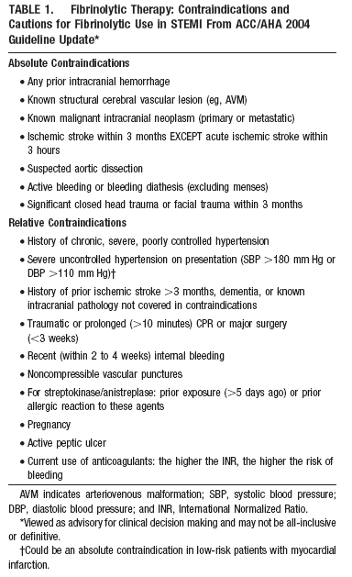

ST segment elevation or new or presumably new LBBB: Evaluation for reperfusion
